Stopping omxplayer
There is a problem if the audio track plays into the next location. The system cycles through looking for a location to play an audio track. When it finds a location, the system stops cycling and directs omxplayer to play the audio track. If this track plays while the train reaches the next location, the next audio track will be missed.
The solution is to a) keep the system cycling and b) to stop omxplayer before the next location is reached.
The program threading_6.py starts the play_clip, at the count of 204 and then stops omxplayer at the count of 9. It then ends at the count of 14.
However there is a problem with the command
After this command is executed, the up arrow key works to re-run the program, BUT the python threading_6.py not displayed on the terminal screen.
NONE of the keyboard strokes are displayed on the screen!

This may not cause a problem, BUT it needs to be explained.
It is interesting that sequence of the commands is:
Kill omxplayer
Print ‘Stopping OMXPLAYER’
Print 209

The execution is:
Print ‘Stopping OMXPLAYER’
Print 209
Kill omxplayer

This is the source code for threading_6.py
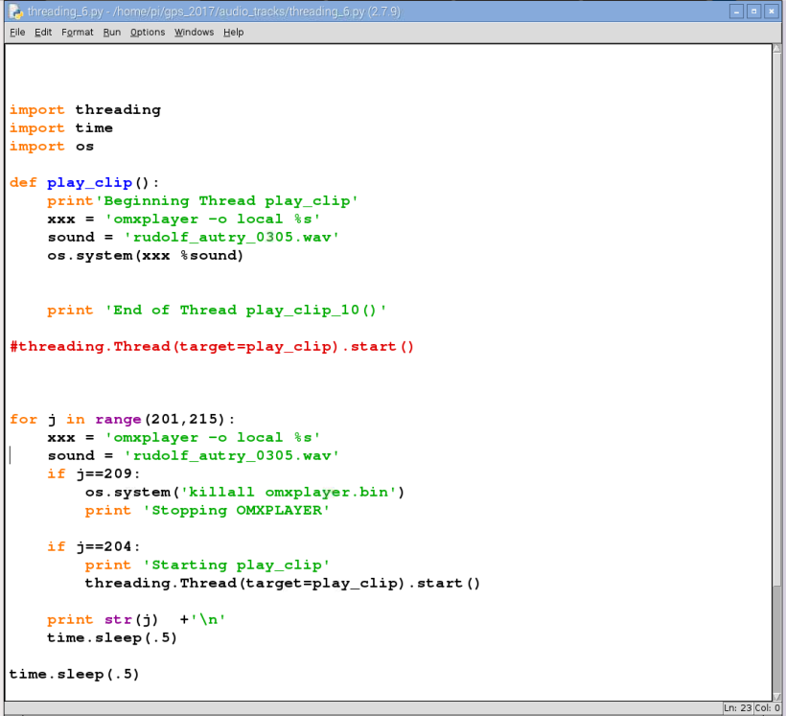

Screen Capture
